**BP315 Business Sub-Process Design Document**

**Fleet Management**

**Supply Chain Management**

**SAP Plant Maintainance**

Table of Contents

1 Overview 3

1.1 Change History 3

1.2 RASCI 3

1.3 Approval Detail 3

1.4 Other Related Documents 3

2 Business Process Overview 4

2.1 High level requirements 4

2.2 Key Value Drivers for the Business Process 4

2.3 Leading Practice Inputs 5

3 Business Sub-Process Description 5

3.1 Business Sub-Process diagram 6

4 Sub Process Activities 6

4.1 Activity List 6

4.2 Inbound Communication 8

4.3 Outbound Communication 8

4.4 Test Conditions 8

5 Sub-Process Variation 9

5.1 Business Unit Led 9

5.2 Geography/Legal Entity Led 9

6 Role Definition & Organisational Impact 9

6.1 Role/Skill Class Inventory 9

6.2 Role Summary 9

6.3 Organizational Impact 10

7 Process Fitness & Gap Analysis 11

7.1 Process Fitness 11

7.2 Gap Analysis 11

8 RICEFW 11

8.1 Reports 11

8.2 Interfaces (Inbound / Outbound) 12

8.3 Conversions 12

8.4 Enhancements 12

8.5 Forms 13

8.6 Workflows 13

9 Integration Points 14

9.1 Integration Issues 14

9.2 Other issues 14

# Overview

With the help of fleet management, the fleet objects from the company’s transport fleet can be displayed in SAP system. Fleet objects are generally showed as Fleet equipment. The fleet relevant data is displayed in equipment with two additional tabs. These tabs contain data such as the license plate number, load volume, consumption data, fuel card number, engine data, fuel type and so on.

## Change History

|  |  |  |  |  |
| --- | --- | --- | --- | --- |
| Ver. | Date | Summary of Changes | Author | Transport Number |
| 1 | 29/06/2017 | Initial Draft | Rahul Soni |  |
| 2 | 10/02/2020 | Document updated | Rishabh Rastogi |  |
|  |  |  |  |  |

## RASCI

|  |  |  |  |
| --- | --- | --- | --- |
| RASCI | Role | Name | Phone |
|  |  |  |  |
|  |  |  |  |
|  |  |  |  |

R: Responsible; A: Accountable; S: Support; C: Contribute; I: Information;

## Approval Detail

|  |  |  |  |
| --- | --- | --- | --- |
| Review # | Date | Name & Position of Approver | Signature |
|  |  |  |  |
|  |  |  |  |

## Other Related Documents

NA

|  |  |
| --- | --- |
| Related Document | Comment |
|  |  |
|  |  |
|  |  |
|  |  |

# Business Process Overview

As fleet objects are treated as equipment in SAP system, it can be used in notification and order as reference object to perform maintenance activity. It can also be used in task lists to define the tasks need to be performed during the maintenance of fleet object. The maintenance planning can be done on the fleet object and the date for maintenance can be calculated based on the distance counter (distance travelled in odometer), time counter (e.g. every 3 months) or using other counter specific to that fleet object.

To maintain fleet object, following information need to be collected:

**Master Data:** With special views of the license plate number, load volume, consumption data, fuel card number, engine data, fuel type

**Consumption calculation:** Calculation of Fuel (Diesel, Petrol, Oil, Gas etc) with respect to time and distance travelled.

**Fuel entry:** FuelEntry per vehicle for Performance analysis.

## High level requirements

This function is used to create fleet specific information in SAP system. With this, we can create fleet as equipment with two additional tabs i.e. Vehicle ID and Vehicle Technology. These tabs contain feet specific data like license plate number, engine data, load volume, fuel card number, fuel type etc. Measuring positions for fuel and distance are used to calculate the consumption of fuel based on kilometre run by the vehicle. These results are recorded with special measurement documents called Consumption based measurement document. Like all other equipment, Fleet equipment can also be used as reference to task list, notification, order and maintenance plan. We can schedule the date for the next service based on the distance travelled, fuel consumed or time counter.

## Key Value Drivers for the Business Process

The Key value drivers for the Business Process are listed below:

Fleet Equipment downtime is decreased and the number of major repairs is reduced.

Better conservation of assets and increased life expectancy of assets, thereby eliminating premature replacement of Fleet.

Display of consumption of fuel and distance by Fleet.

Data management can be as general (full fleet) or as granular (individual components, drivers, and equipment) as needed. Its ability to account for differences of language, exchange rates, and even culture make it a good choice for businesses and fleets with a global presence.

Data Analyses can be run quickly and easily, with several options to dissect and analyze large amounts of data (showing areas of opportunity or cost control). Perhaps most importantly, the system has very low downtime, so it's always on-call when it's needed

## Leading Practice Inputs

Maintenance to be performed on Fleet as per Statutory requirement and local laws.

Timely, routine repairs circumvent fewer large-scale repairs.

Results in Improved safety and quality conditions for everyone.

Maintenance to be performed on Fleet per manufactures recommendation guide

# Business Sub-Process Description

Fleet management is mainly used for Vehicles Equipment in Mining Plants. Maintenance of Vehicles will be done as per standard breakdown and Preventive maintenance order. To perform the maintenance activity on fleet object, measuring points need to be assigned which calculates the consumption values. The consumption value in fleet management can refer to:

**Fuel counter:** It measures the fuel or energy consumed by fleet

**Performance counter:** It is also called primary counter that is used to calculate the time or distance (e.g. 3 months or 10,000 kilometres) covered by vehicle

Apart from above mention counter, several different counters can be defined based on specific requirements to calculate vehicle data. These counters are referred when calculating consumption data. The consumption value or calculation method for fleet can be calculated with the following units of measurement

Litre per kilometre

Miles per gallon

Litre per hour

Litre per mile.

## Business Sub-Process diagram

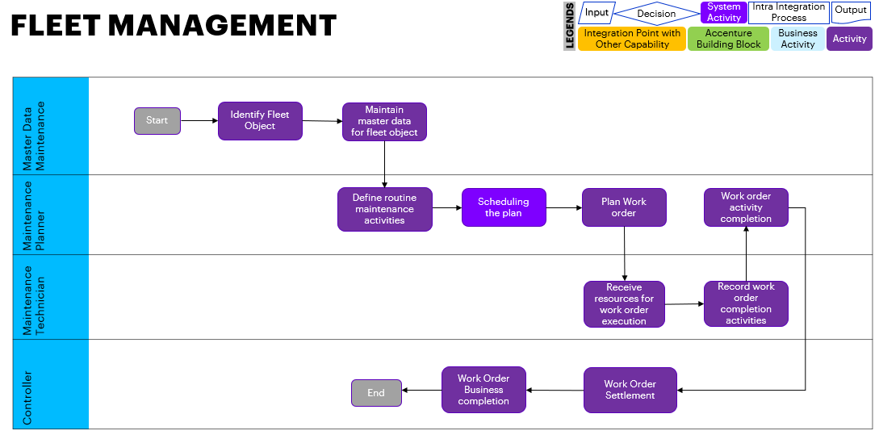

# Sub Process Activities

## Activity List

|  |  |  |  |  |
| --- | --- | --- | --- | --- |
| Name | Description | Fiori App | Roles involved | Regulatory /Other Controls |
| Create Fleet Equipment | Define the objects that are considered as fleet | Create Fleet Object | Maintenance Planner |  |
| Maintain Vehicle ID and Engine Data | Maintain data related to fleet | Change Equipment | Maintenance Planner |  |
| Assign Measuring point to the equipment | To measure the fuel consumed | Change Equipment | Maintenance Planner |  |
| Create Measurement document | Measurement reading is recorded using measurement document | Create measurement document | Maintenance Planner |  |
| Create counter based Maintenance Plan for Fleet | Maintenance plan is created to schedule service when a desired performance or time has reached | Create Maintenance Plan | Maintenance Planner |  |
| Schedule Maintenance Plan for Fleet | Schedule Maintenance plan to get the desired dates for maintenance | Schedule maintenance plan | Maintenance Planner |  |
| Work order generated | Work order will be generated as call objects to perform maintenance | Change Maintenance Plan | Maintenance Planner |  |
| Work order Release | Release work order to perform the tasks for maintenance | Change maintenance Order | Maintenance Planner |  |
| Create Purchase requisition | Purchase requisition is created to get the approval of any external resources/material needed during maintenance | Change maintenance Order | Purchaser |  |
| Goods issue and work order completion | Issue required materials from warehouse to order. | Post Goods Issue: MIGO_GI | Inventory Manager |  |
| Time Confirmation | Enter the time taken during maintenance activity | Enter PM Order confirmation | Maintenance Technician |  |
| Technically Complete Work Order (TECO) | After all the maintenance activity is done order is said to be completed “Technically” | Change maintenance Order | Maintenance Technician |  |
| Record consumption Measuring document | It is used to analyses fuel consumption for fleet | Consumption transaction | Maintenance Planners |  |
| Cost Settlement | All the cost incurred during maintenance activity is settled | Actual Cost Settlement | Controller |  |
| Close Work Order | Work order is closed as all activities are completed and cost is settled. | Change maintenance Order | Maintenance Planner |  |

## Inbound Communication

NA

|  |  |  |  |  |
| --- | --- | --- | --- | --- |
| Activity | Type (email, form, handoff, etc) | Automatic/Manual | Source | Description |
|  |  |  |  |  |
|  |  |  |  |  |

## Outbound Communication

NA

|  |  |  |  |  |
| --- | --- | --- | --- | --- |
| Activity | Type (email, form, handoff, etc) | Automatic/Manual | Source | Description |
|  |  |  |  |  |
|  |  |  |  |  |

## Test Conditions

|  |  |  |
| --- | --- | --- |
| Number | Test Condition – Action | Expected Result |
|  |  |  |
|  |  |  |

# Sub-Process Variation

## Business Unit Led

None

## Geography/Legal Entity Led

None

# Role Definition & Organisational Impact

NA

## Role/Skill Class Inventory

|  |  |  |
| --- | --- | --- |
| Role | Skills | Knowledge |
|  |  |  |
|  |  |  |
|  |  |  |

## Role Summary

|  |  |  |
| --- | --- | --- |
| Role | List of Steps | Fiori App |
| Maintenance Planner | Create Fleet Equipment | Create Equipment |
| Maintenance Planner | Maintain Vehicle ID and Engine Data | Change Equipment |
| Maintenance Planner | Assign Measuring point to the equipment | Change Equipment |
| Maintenance Planner | Create Measurement document | Create measurement document |
| Maintenance Planner | Create counter based Maintenance Plan for Fleet | Create Maintenance Plan |
| Maintenance Planner | Schedule Maintenance Plan for Fleet | Schedule maintenance plan |
| Maintenance Planner | Work order generated | Change Maintenance Plan |
| Maintenance Planner | Work order Release | Change maintenance Order |
| Purchaser | Create Purchase requisition | Change maintenance Order |
| Inventory Manager | Goods issue and work order completion | Post Goods Issue: MIGO_GI |
| Maintenance Technician | Time Confirmation | Enter PM Order confirmation |
| Maintenance Technician | Technically Complete Work Order (TECO) | Change maintenance Order |
| Maintenance Planner | Record consumption Measuring document | Consumption transaction |
| Controller | Cost Settlement | Actual Cost Settlement |
| Maintenance Planner | Close Work Order | Change maintenance Order |

## Organizational Impact

|  |  |  |  |  |
| --- | --- | --- | --- | --- |
| Reference # | Impact Description | Impact (H/M/L) | Impact Type | Impacted Groups |
|  |  |  |  |  |
|  |  |  |  |  |
|  |  |  |  |  |

# Process Fitness & Gap Analysis

NA

## Process Fitness

|  |  |  |  |  |
| --- | --- | --- | --- | --- |
| Req ID | Short Description | Long Description | Req. Type | Accenture Reusable Assets |
|  |  |  |  |  |
|  |  |  |  |  |

## Gap Analysis

|  |  |  |  |  |  |  |
| --- | --- | --- | --- | --- | --- | --- |
| Country/ Region/ Business Impacted | Gap Description | Legal Req. (Y/N) | Magnitude of Impact (L/M/H) | Solution Type | RICEFW No. | Ref. to Req. id. |
|  |  |  |  |  |  |  |
|  |  |  |  |  |  |  |

# RICEFW

NA

## Reports

|  |  |  |  |  |  |
| --- | --- | --- | --- | --- | --- |
| Client XYZ  RICEFW # | Report Description | Complexity (H/M/L) | Comments | Use from myConcerto/ARTL (New/Rework/Rep) | Ref # from RICEFW inventory |
|  |  |  |  |  |  |
|  |  |  |  |  |  |
|  |  |  |  |  |  |

## Interfaces (Inbound / Outbound)

|  |  |  |  |  |  |
| --- | --- | --- | --- | --- | --- |
| Client XYZ  RICEFW # | Interface Description | Complexity  (H/M/L) | Comments | Use from myConcerto/ARTL (New/Rework/Rep) | Ref # from RICEFW inventory |
|  |  |  |  |  |  |
|  |  |  |  |  |  |

## Conversions

|  |  |  |  |  |  |
| --- | --- | --- | --- | --- | --- |
| Client XYZ  RICEFW # | Conversion Description | Complexity  (H/M/L) | Comments | Use from myConcerto/ARTL (New/Rework/Rep) | Ref # from RICEFW inventory |
|  |  |  |  |  |  |
|  |  |  |  |  |  |

## Enhancements

|  |  |  |  |  |  |
| --- | --- | --- | --- | --- | --- |
| Client XYZ  RICEFW # | Enhancement Description | Complexity  (H/M/L) | Comments | Use from myConcerto/ARTL (New/Rework/Rep) | Ref # from RICEFW inventory |
|  |  |  |  |  |  |
|  |  |  |  |  |  |
|  |  |  |  |  |  |

## Forms

|  |  |  |  |  |  |
| --- | --- | --- | --- | --- | --- |
| Client XYZ RICEFW # | Form Description | Complexity (H/M/L) | Comments | Use from myConcerto/ARTL (New/Rework/Rep) | Ref # from RICEFW inventory |
|  |  |  |  |  |  |
|  |  |  |  |  |  |

## Workflows

|  |  |  |  |  |  |
| --- | --- | --- | --- | --- | --- |
| Client XYZ RICEFW # | Workflow Description | Complexity (H/M/L) | Comments | Use from myConcerto (New/Rework/Rep) | Ref # from RICEFW inventory |
|  |  |  |  |  |  |
|  |  |  |  |  |  |

# Integration Points

NA

## Integration Issues

|  |  |  |  |  |
| --- | --- | --- | --- | --- |
| Issue # | Issue Description | Impact | Status | Resolution |
|  |  |  |  |  |
|  |  |  |  |  |

## Other issues

|  |  |  |  |  |
| --- | --- | --- | --- | --- |
| Issue # | Issue Description | Impact | Status | Resolution |
|  |  |  |  |  |
|  |  |  |  |  |

#### Revision History

|  |  |  |  |
| --- | --- | --- | --- |
| Date | Version | Description | Author |
| DD/MM/YYYY |  |  |  |
|  |  |  |  |
|  |  |  |  |